**Node.js Project 2: Small Project on Templates**

Rehearsing the skills on

* Utilize EJS template engine with Express.js
* Parse JSON files using EJS templates

**TASK:**

**Apply EJS/PUG templates to the site you created in project 1. Utilize partials and dynamic data.**

**Return the code to Github and Deploy to Heroku. Return links to Optima 26.3.2020.**

**Part A: Partials and templates (10 p.)**

1. Split up the main page of your site to at least 3 different partials (for example, header, content, footer). Think which would be good sections of the page to separate as partials and why?
2. Then create index.ejs template and use include-tags which will combine the files from partials.
3. Apply proper code in the Node.js application which will utilize the templates and and display the site.
4. The template that handles /message –route should receive the data from Node-server as JSON object and render the template using for/foreach loop within EJS/PUG.
5. Return code to Github. Deploy it to Heroku. Return heroku link to Optima/GitHub.

**Part C: Add new messages ( 4 p. )**   
  
Make a copy of the working app created on part B and continue from there with part C.

1. /newmessage –route should add an input form to the page template created on part A. From should have fields for the following data: username, country and message and a button which enables user to send it.   
     
   When the form is submitted, the collected data should be saved as JSON data to the data file generated on step 5. Sample dataset can be seen below:  
     
   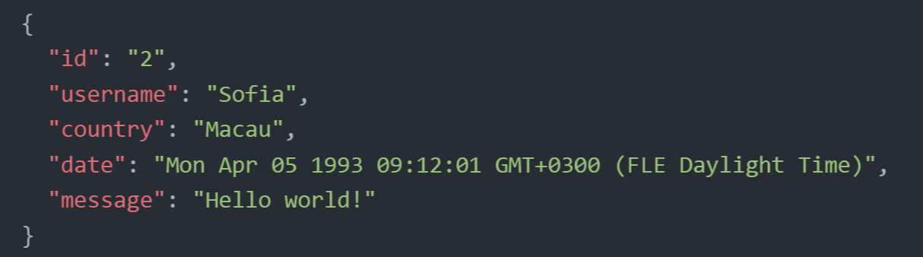  
     
   Use JavaScripts Date() –function to store the timestamp of the submission. Id is not necessary in our app, but if you wish, you can create one for each item as well.